**Documentation for Test Units**

Client Side

1. Login Activity

The normal Login Activity is shown like below (Pic 1-1):

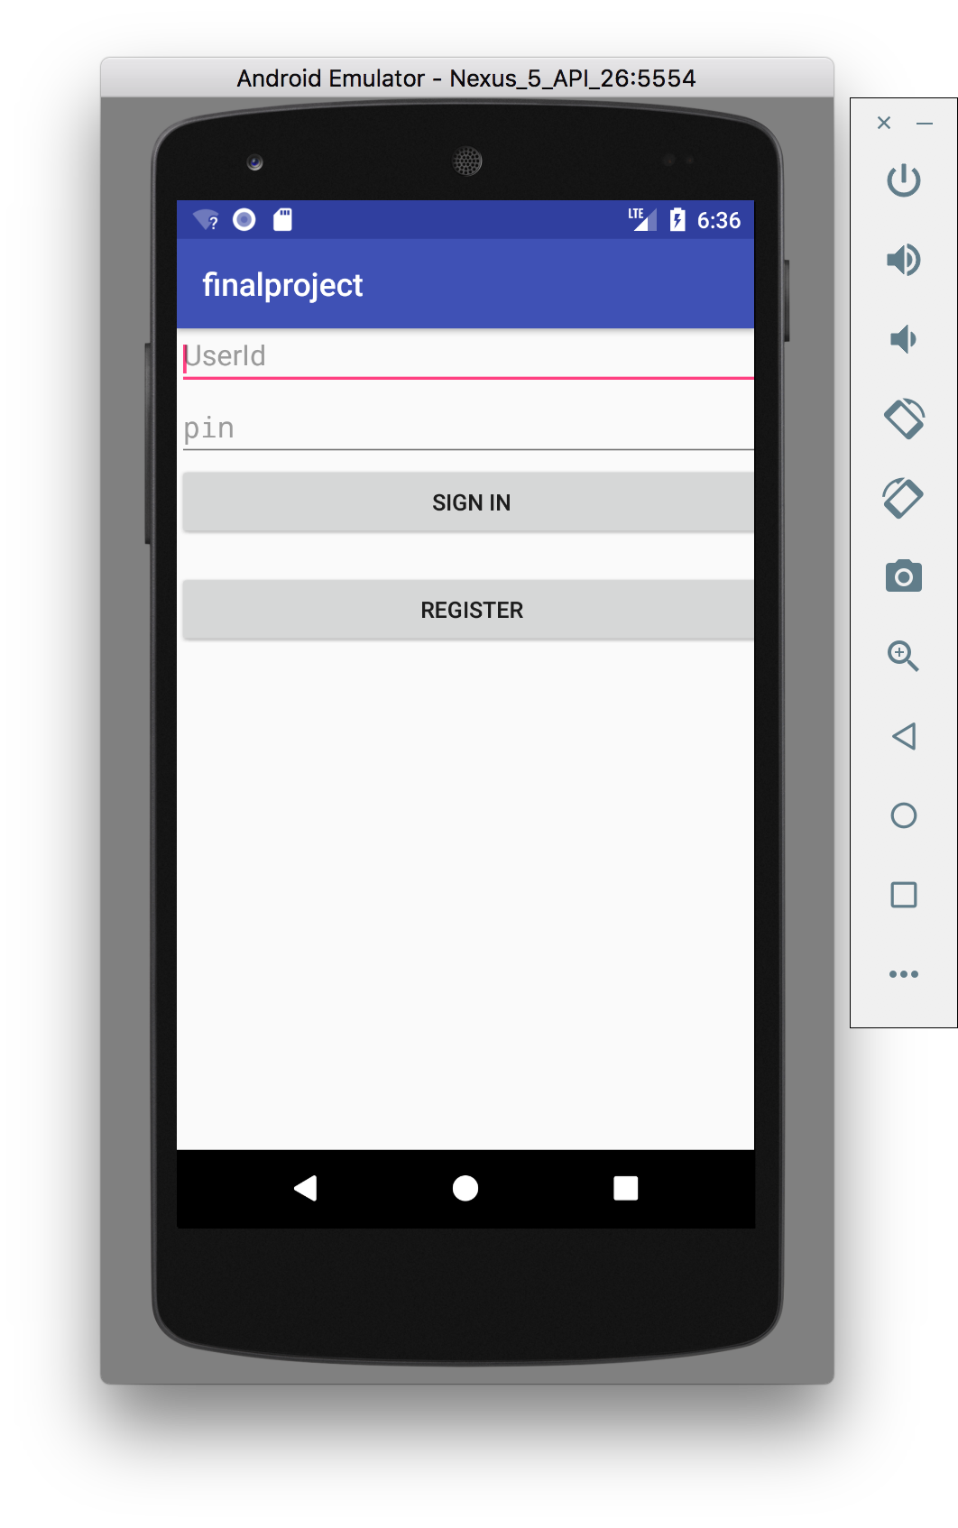

Pic 1-1

First step: when the Chef doesn’t login and click the “SIGN IN”, an AlertDialog will notify the customer the restaurant is not opened (Pic 1-2).

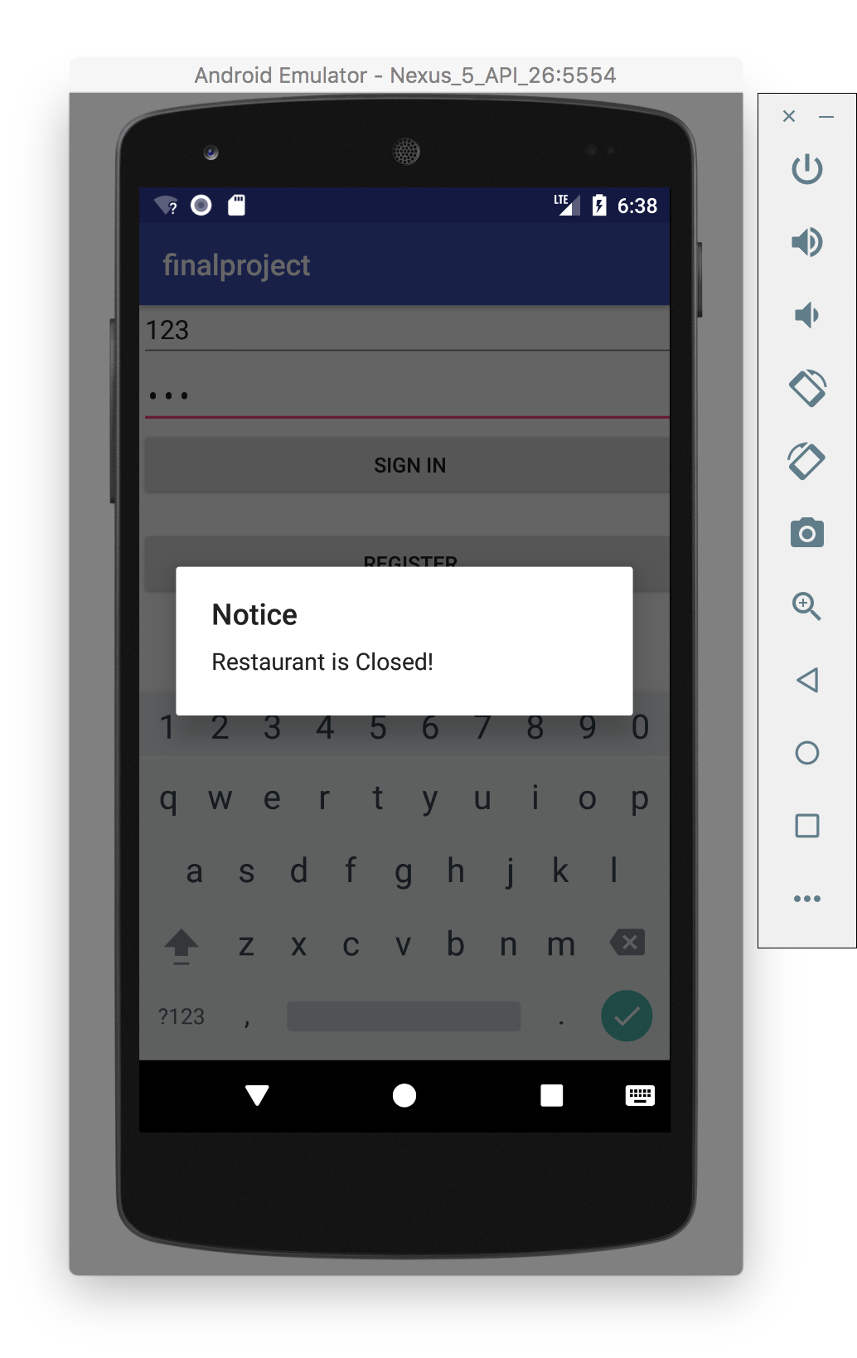

Pic 1-2

Second step: after clicked the “REGISTER”, the register activity will show like below (Pic 1-3).

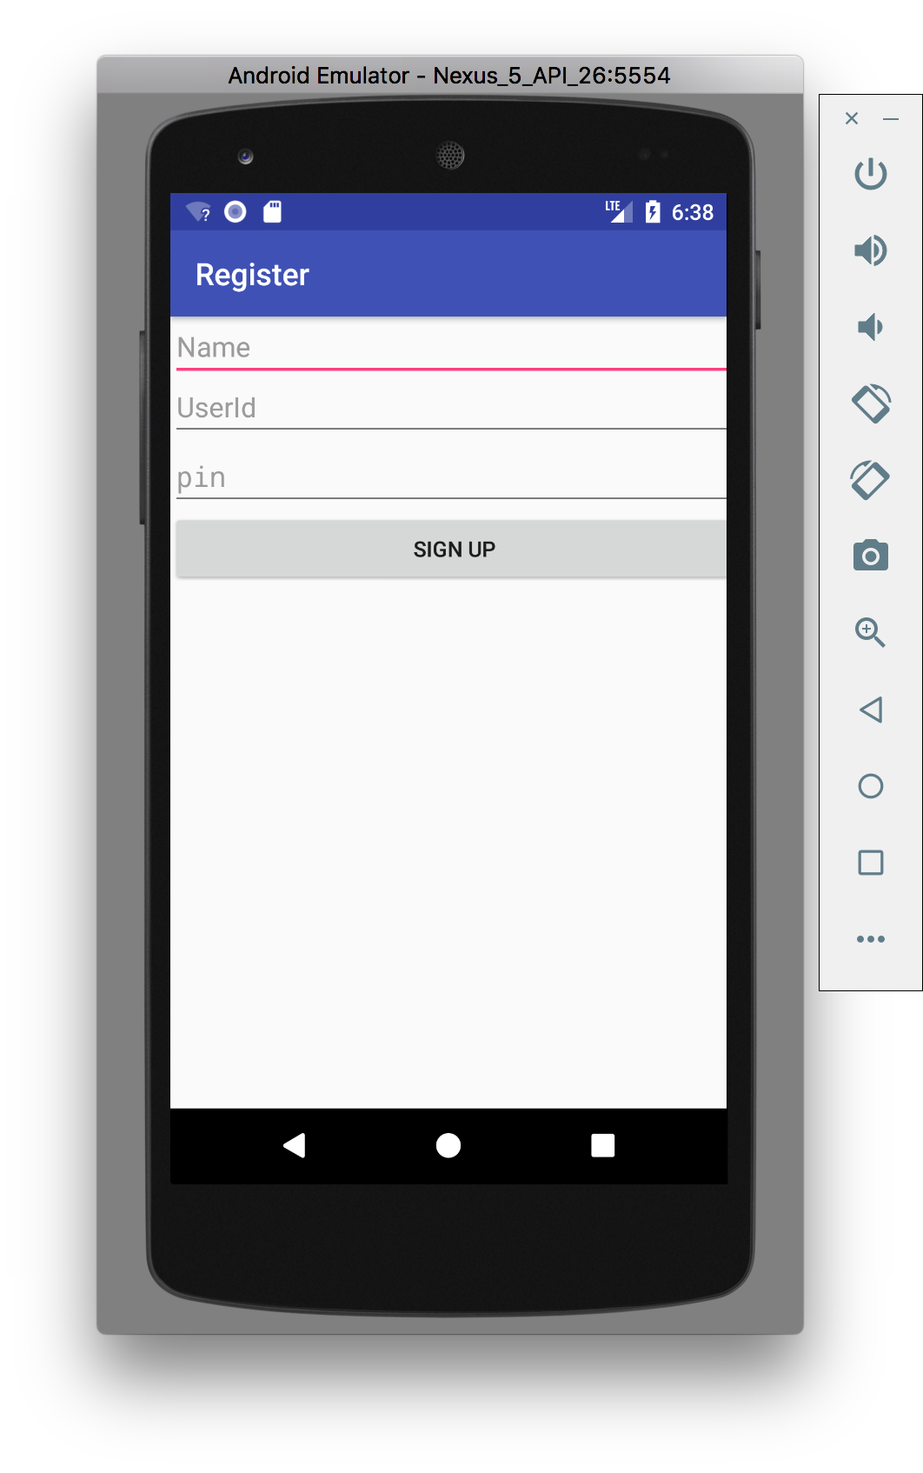

Pic 1-3

1. Menu Activity

The normal Menu Activity is shown like below (Pic 2-1):

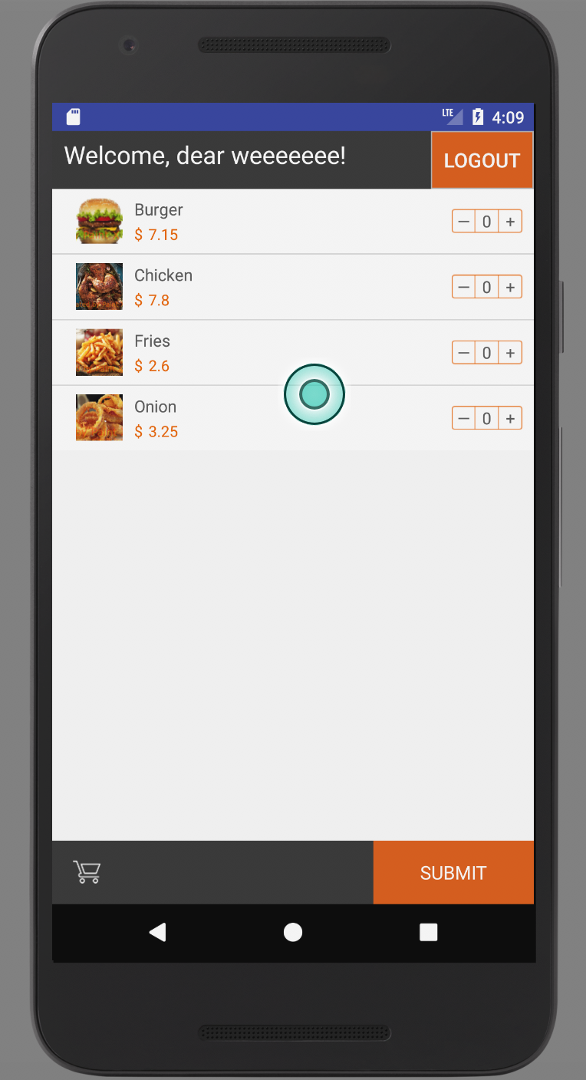

Pic 2-1

First step: select no item and click “SUBMIT”, the activity will show an Alert Dialog to warn the customer that can’t send a void order that contains no order item (Pic 2-2).

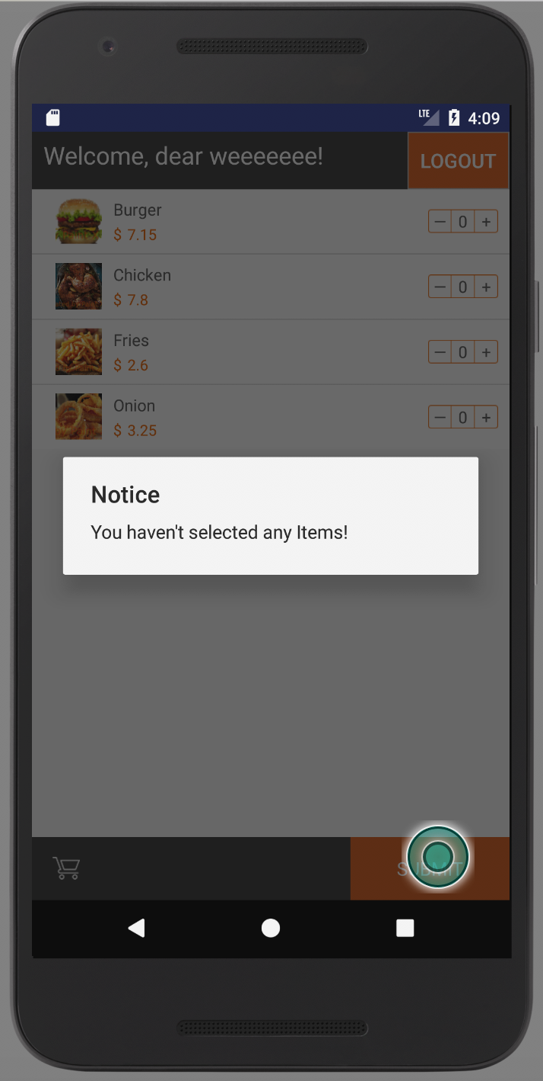

Pic 2-2

Second step: select some items but not exceed the number in the InventoryList, the total price of the selected order items will show in the bottom of the screen (Pic 2-3). And click “SUBMIT”, the activity will jump to Review Activity normally (Screenshot will be shown next part).

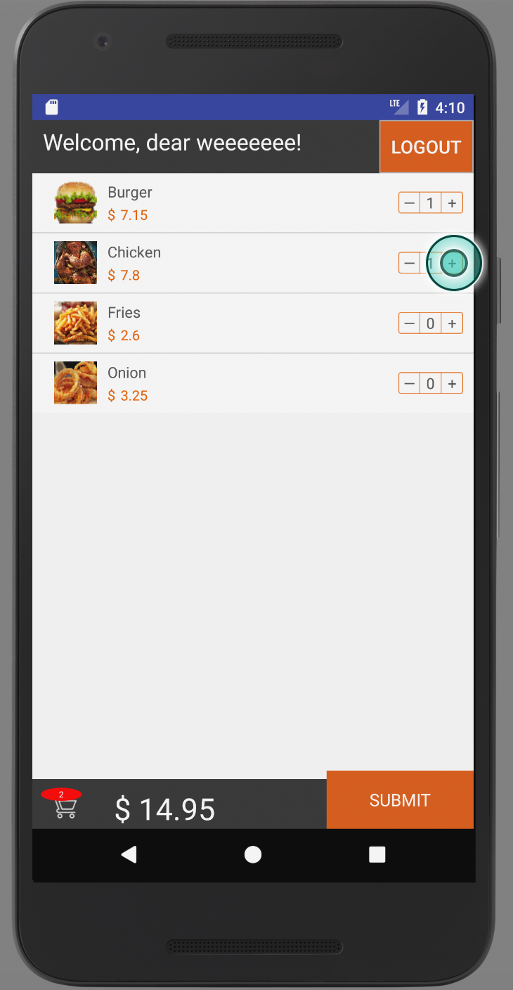

Pic 2-3

Third step: select some items and exceed the number in the InventoryList and click “SUMBIT”, the activity will jump to Review Activity normally. (Screenshot will be shown next part.)

Forth step: click “LOGOUT”, the activity will jump to Login Activity.

1. Review Activity

When the quantity of the order items that customer selected doesn’t exceed the number in the InventoryList, the Review Activity is shown like below (Pic 3-1):

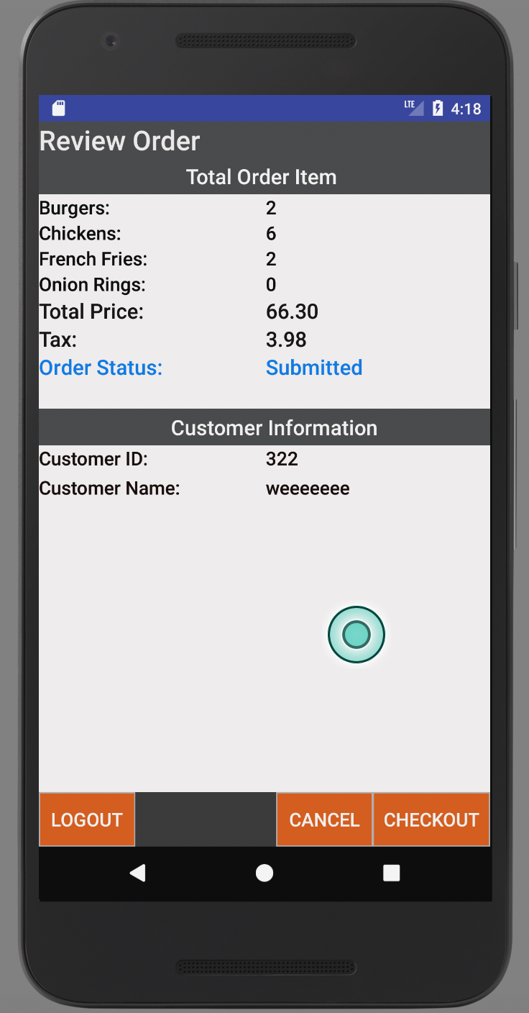

Pic 3-1

When the quantity of the order items that customer selected exceeds the number in the InventoryList, the Review Activity is shown like below (Pic 3-2):

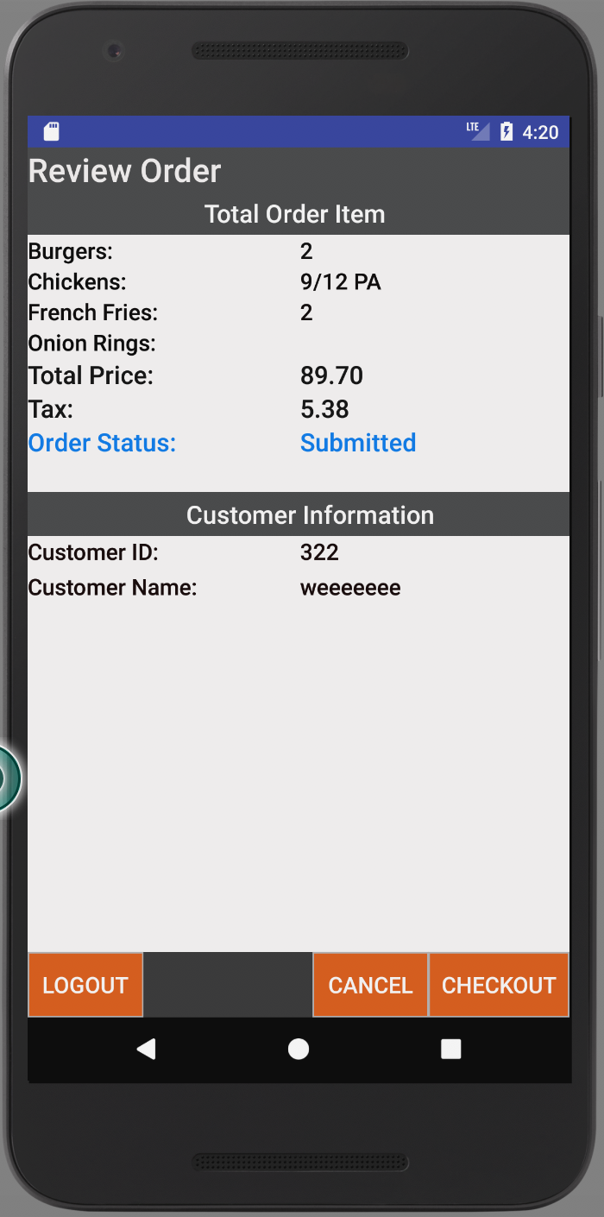

Pic 3-2

First step: click “CANCEL”, the activity will jump to Menu Activity, and customer can make a new order.

Second step: click “CHECKOUT”, an AlertDialog will show to notify the customer the order has been checked out (Pic 3-3), and the “Status” of the order will be changed to “Receiving”, and the “Partially Available” signal will disappear (Pic 3-4).

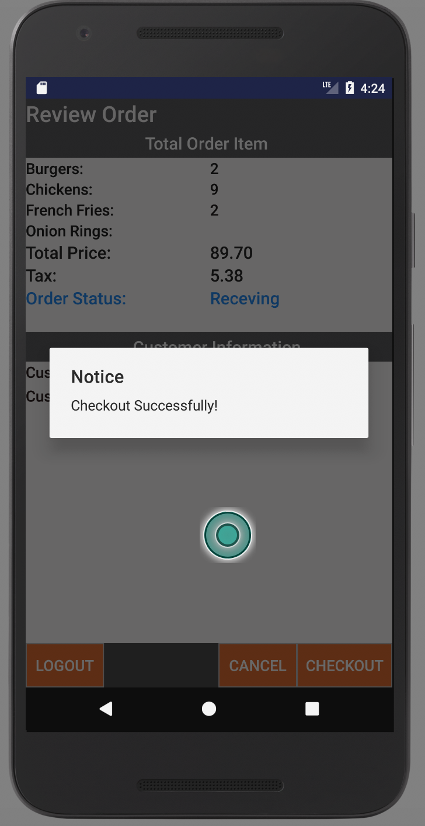

Pic 3-3

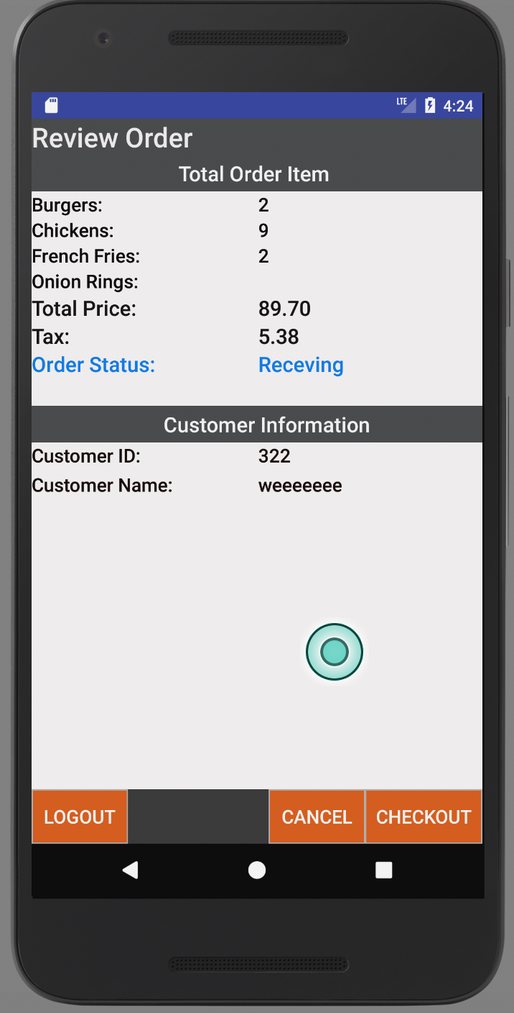

Pic 3-4

Third step: after the server sending the notice that the food is Packaging, an AlertDialog will show to notify the customer (Pic 3-5), and the “Status” will also change.

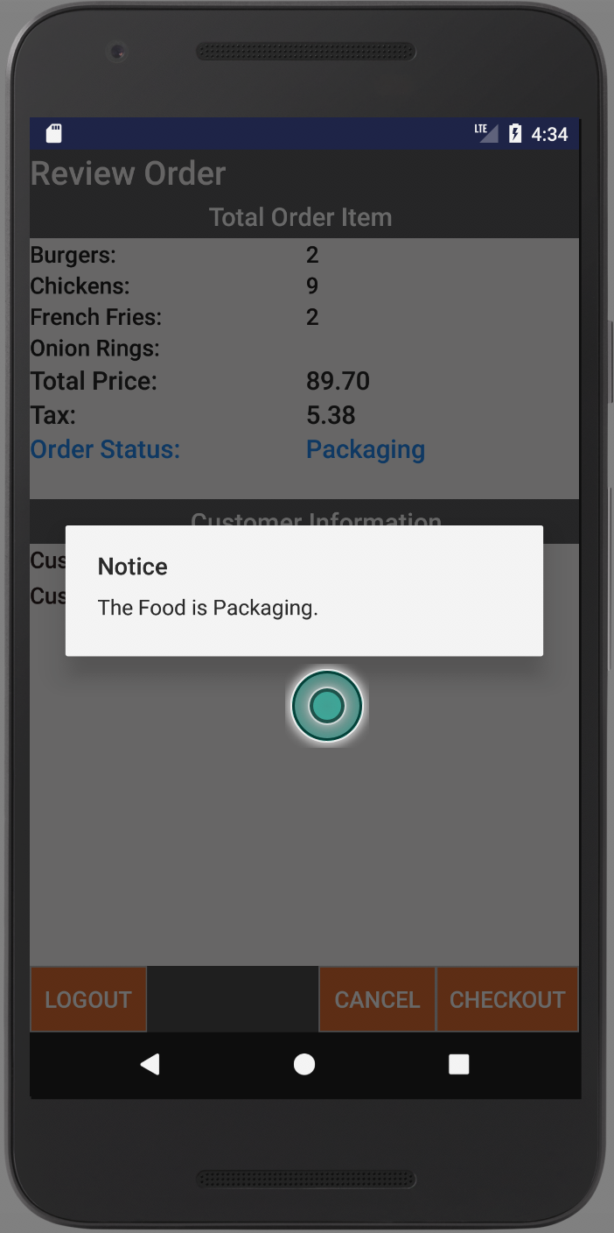

Pic 3-5

Forth step: after the server sending the notice that the food is Ready, an AlertDialog will show to notify the customer (Pic 3-6), and the “Status” will also change.

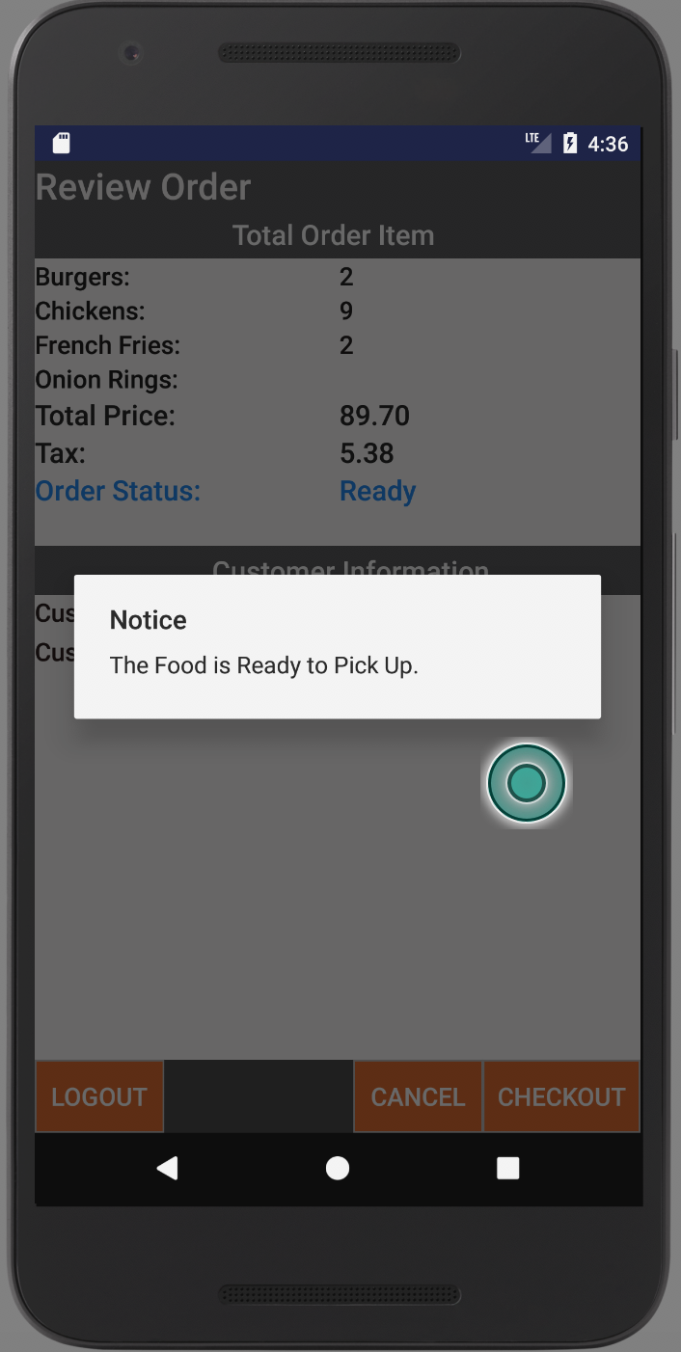

Pic 3-6

Fifth step: click “LOGOUT”, the activity will jump to Login Activity.

Server Side

Running process is shown as below:

